User Documentation

Installation

1. Download photoshare.tgz and put it into the folder you want your web documents to be created in
2. Extract the files in photoshare.tgz using the command tar xzvf photoshare.tgz
3. Set the permissions with the command chmod –R 777.
4. Run setup.sql to initialize the database tables
5. Go into setup.php and enter you oracle username and password

User Manual

Main Page (index.php)

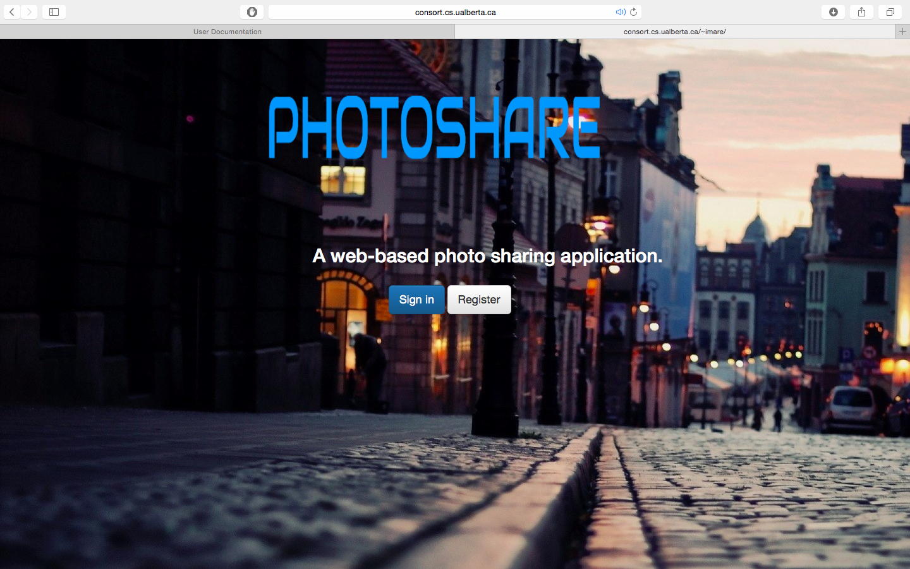

This is the main page that is displayed when the website is called. You can either login or register. If you have already done either of these actions and not logged out, you are automatically logged in and set to your profile.

Usermanagement Module

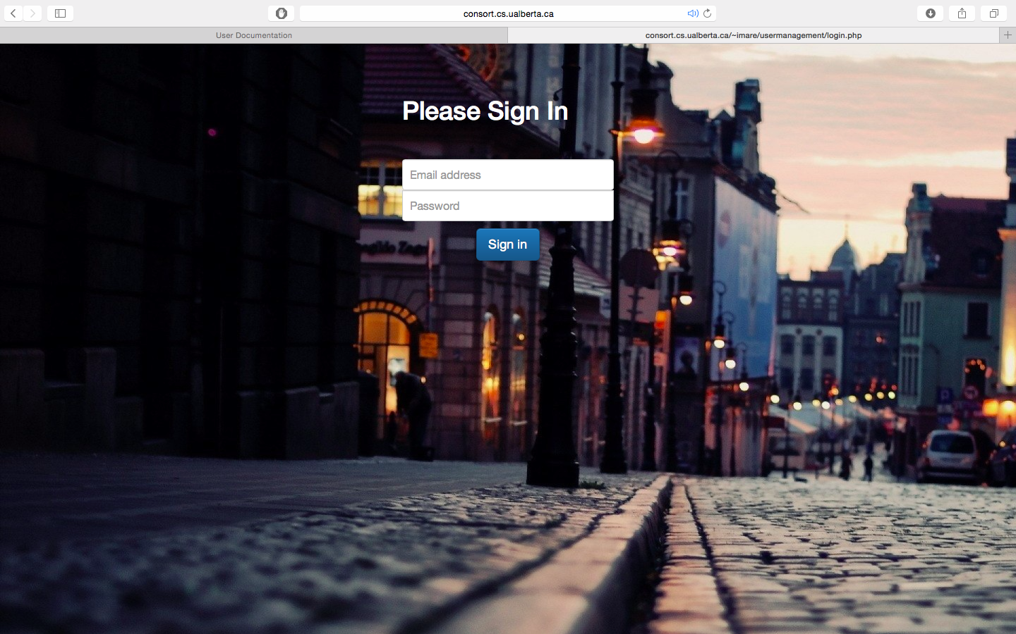

Once you have clicked the sign in button, you be redirected to this page where you are presented with a form to input your username and password. Once you have entered your information, the sign in button is clicked, and your have correctly entered your password and username you will be redirected to your profile. If the user name or password is invalid then an error message is displayed

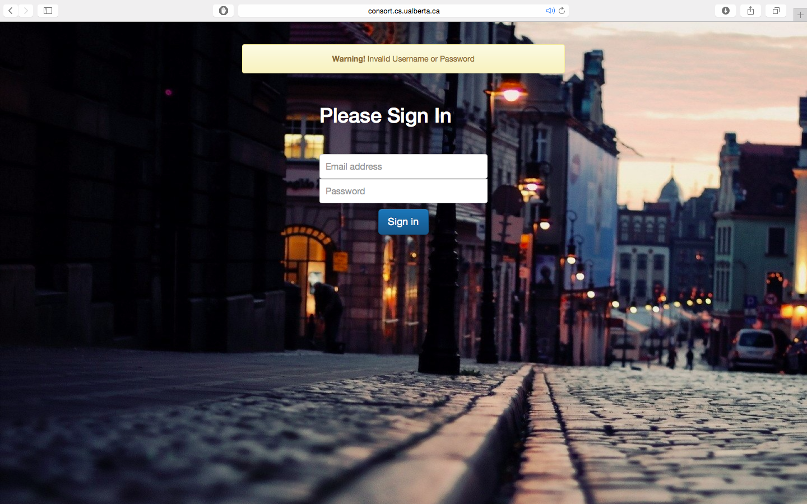

If you click the register button on the homepage you will be redirected to provide some basic information

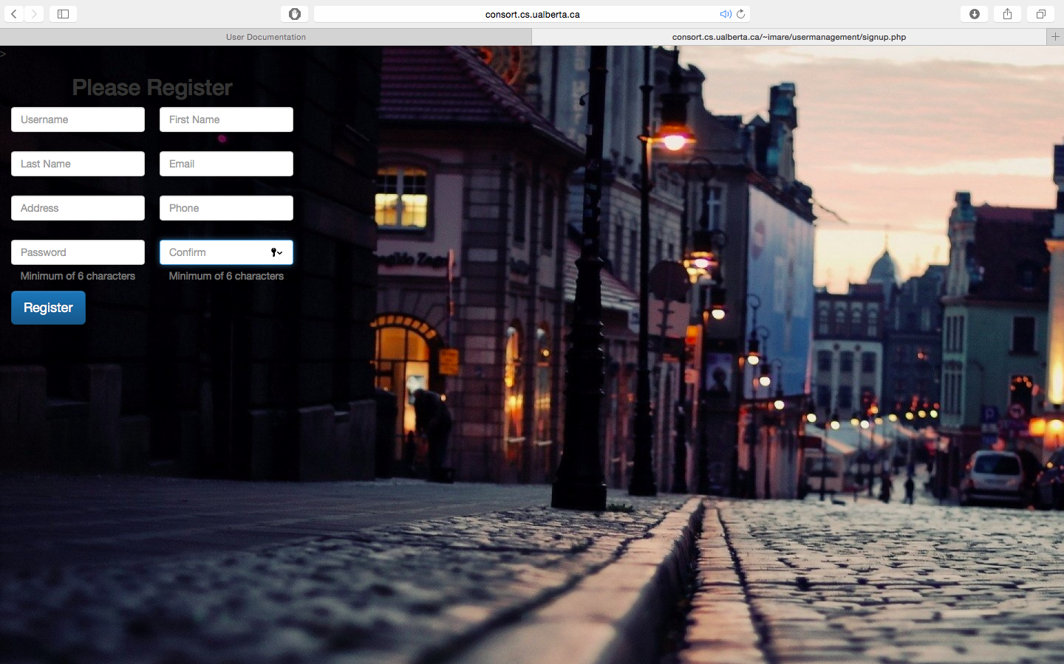

If

* Passwords do not match
* User name is too short / password to short
* Email is invalid
* Phone number is invalid

The user will be displayed an error message and be placed back onto this page

If the user signs is or registers successfully, the profile page will be called

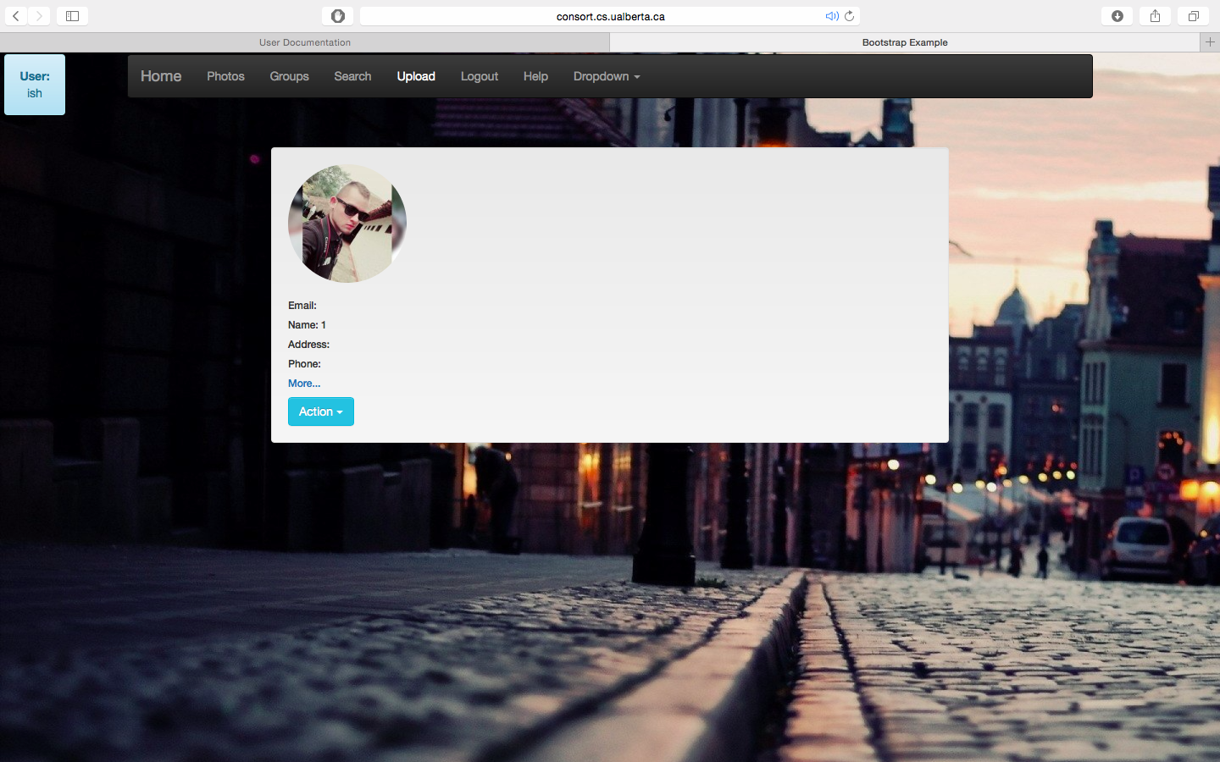

.

Logout

The logout button is displayed in the header at the top of the webpage. Clicking this button will simply logout the user

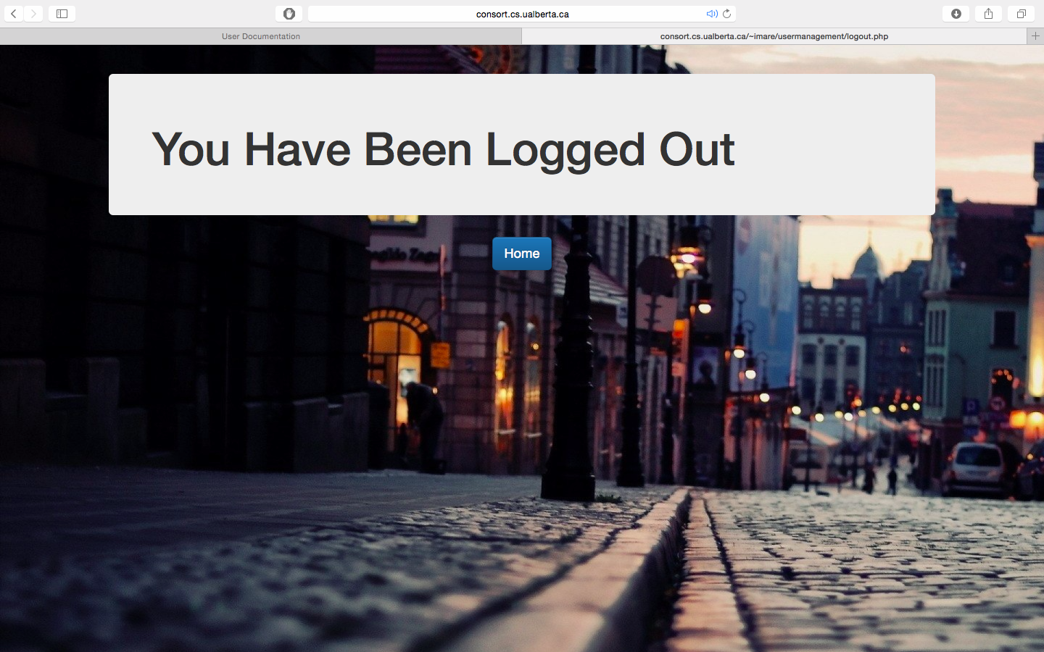

Upload Module

Search Module

Display Module

Security Module

Data Analysis Module

If the user who